**Importing Datasets**

**TOTAL POINTS 8**

1.Question 1

What is a header?



name of the rows



name of the columns

1 point

2.Question 2

What do we want to predict from the dataset?



price



colour



make

1 point

3.Question 3

What library is primarily used for data analysis



matplotlib



pandas



scikit-learn

1 point

4.Question 4

Select the libraries you will use for this course?



matplotlib



pandas



scikit-learn

1 point

5.Question 5

How would you check the bottom 10 rows of dataframe **df?**



df.tail(10)



df.tail()



df.head()

1 point

6.Question 6

What task does the following command perform?



1

2

df.to_csv("A.csv")



change the name of the column to "A.csv"



load the data from a csv file called "A" into a dataframe



Save the dataframe df to a csv file called "A.csv"

1 point

7.Question 7

Consider the segment of the following dataframe:

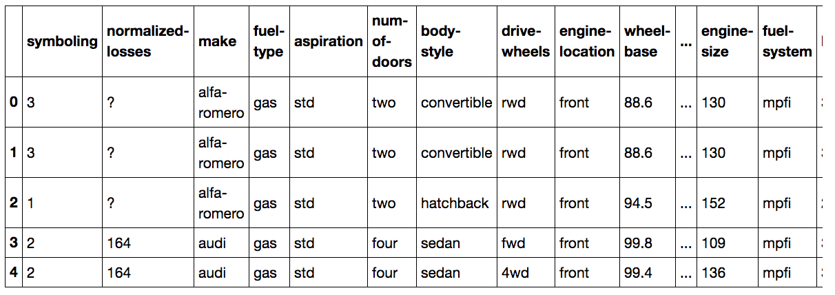

What is the type of the column **make**?



int64



object



float64

1 point

8.Question 8

If you use the method **describe()** without changing any of the arguments you will get a statistical summary of all the columns of type object?



false



true

1 point